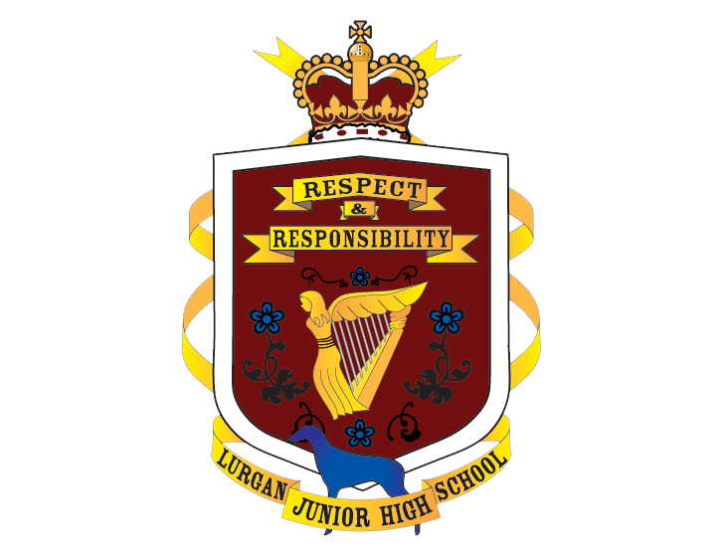

Lurgan Junior High School
Mobile Phone Policy
Personnel Responsible: Principal. Approved by Board of Governors: October, 2025. Period & Date for Review: Every three years; 2027-28.

Contents

Rationale 2
Aims 2
Objective 2
Advice for Parents 3
Mobile Phones at Lurgan Junior High School 3
Safe Online Behaviour 4
Evaluation 4

Rationale
Lurgan Junior High School recognises that mobile phones are an important aspect of everyone’s life and have considerable value particularly in relation to individual safety. The school accepts that there may be genuine reasons for their use travelling to and from school and, as such, phones are allowed in school, but must be switched off before entering the school grounds and remain switched off in an inside blazer pocket until the pupil leaves the school grounds at the end of the school day.
Pupils are expected to demonstrate Responsibility, one of our core school values, by ensuring their phone is switched off, stored safely, and used appropriately in line with school procedures.

Aims & Objectives
- The aim of this policy is to ensure that parents, pupils, and staff are fully aware of, and understand the rationale of the school policy on mobile phone usage, through clear communication at the start of each academic year and throughout it.
- To promote and reinforce the value of Responsibility by educating pupils on the safe and appropriate use of mobile phones through the preventative curriculum.
- To promote, through the policy, acceptable behaviours in relation to responsible mobile phone usage. This will be evidenced by a reduction in incidents of phone misuse recorded on SIMS by the end of each academic year.

Advice for Parents
The school will not accept any responsibility for mobile phones brought into school or taken on trips by pupils. We suggest that parents take out insurance cover if mobile phones are to be brought into school and that more expensive models are not used. School does not operate a ‘Bring Your Own Device’ (BYOD) policy and therefore accepts no liability for loss or damage to any electronic device. It is advisable to protect phones with security markings and codes.
We ask that parents take time to familiarise themselves with the legal age requirements for social media platforms in the United Kingdom, as many popular apps and sites have a minimum age of 13 or older. We also encourage open and ongoing conversations between parents and their children about online activity, digital behaviour, and the responsible use of mobile phones. Parents are encouraged to research healthy online habits together with their son or daughter to help promote a balanced, safe, and positive digital lifestyle.

At Lurgan Junior High School, we promote the values of Respect, Responsibility, and Resilience in all areas of school life, including online behaviour and mobile phone use. Online devices can expose pupils to inappropriate or harmful material, which raises serious safeguarding and legal concerns.

We, therefore, strongly encourage parents and guardians to take an active role in monitoring their child’s online activity, ensuring they use technology safely, respectfully, and responsibly. Pupils should be taught that their digital actions have real-world consequences (including legal ramifications) and that treating others online with kindness and respect is essential.

Mobile Phones at Lurgan Junior High School
Pupils must switch off mobile phones before entering the school grounds and keep their phone in an inside blazer pocket at all times.

If a pupil’s phone is used, seen or heard anywhere on the school grounds, it will be confiscated by a member of staff and lodged with the Main Office. On the first occasion, a pupil whose phone has been confiscated may report to the Main Office at the end of the school day to reclaim the phone. This will be communicated to the pupil’s parent(s) via a message on SIMS Parent App and a record of this will be retained in the office.

On subsequent occasions, parents are requested to collect their child’s mobile phone at the Main Office on Friday afternoon between 3.30pm and 4pm.

Pupils who have a genuine emergency can use the school phone to contact parents at any time with a teacher’s permission. Similarly, if parents have an emergency and need to contact their son/daughter, then they should phone the school office (028 3832 3243) in the usual way and a message will be passed on to the child.

Should there be a whole school emergency, such as heavy snowfall which may cause early closing, pupils will be allowed to use mobile phones to rearrange their transport. In such instances, pupils will be directed to do so by a member of staff.

If pupils leave the classroom to go to the toilet, they should leave their phone on the teacher’s desk until they return from the toilet: this safeguards against inappropriate use of mobile technology in the pupils’ toilets.

We would request that pupils do not have mobile phones on their person or on their desks during examinations or tests. At such times of the year, school would advise that they are kept securely in school bags.

At Lurgan Junior High School, pupils are expected to demonstrate Respect, Responsibility, and Resilience in their use of technology. While smart watches may be worn in school as timepieces, they must not be connected to a mobile phone or used for communication, messaging, or recording purposes at any time. Our stance on mobile phones being switched off before pupils enter the school grounds applies equally to smart watches with similar capabilities. Some devices may remain connected even when the phone is switched off; therefore, pupils must ensure all connectivity functions are disabled during the school day.

Any pupil found using a smart watch for communication, recording, or other inappropriate purposes will be subject to the same procedures as those applied to mobile phone misuse, including first and second confiscation measures. Smart watches are not permitted during examinations or assessments under any circumstances. This is consistent with the Examination and Assessment Procedures which operate during Christmas and Summer examination series, as well as Transfer examinations in the second term for all Year 10 pupils.

Safe Online Behaviour
At Lurgan Junior High School, we expect all pupils to demonstrate respect and responsibility in their online interactions. Everyone has a role to play in creating a safe and supportive digital environment. Pupils are reminded to treat others online with the same courtesy and kindness they would show in person.

Leadership reserves the right to initiate an investigation when a concerned adult or pupil reports that another pupil is suspected of creating and/or disseminating harmful digital material regarding pupils or staff (including, but not limited to; bullying-type behaviour, offensive messages and/or photographs/videos).To support this process, the school may invite the reporting adult or pupil to securely transfer material from their electronic device to the school's centralised and secure system as evidence.

Furthermore, in the interest of safeguarding our pupils and staff, a pupil under investigation may be invited voluntarily to display the material they are suspected of creating or disseminating for investigation purposes. In all such instances, two members of staff will always be present. While pupils retain the right to refuse, exercising this right does not preclude the school from investigating further based on available evidence

In situations where inappropriate mobile phone/online behaviour occurs and is brought to our attention, the school will notify parents to address the issue. Where such incidents have a negative impact on pupils and/or staff, school will follow through with our Positive Behaviour procedures including our Anti-Bullying Policy where applicable. This may range from restorative work to suspension.
Any incident involving indecent images or videos of pupils — whether created, taken, shared, or received on a device — will be treated as a serious safeguarding matter in line with legal guidelines. If such material is brought to the attention of the school or the Safeguarding Team, it will not be investigated internally. Consistent with safeguarding and child protection guidance and legislation, the matter will be immediately referred to the Central Referral Unit (PSNI), by a member of the Safeguarding Team for appropriate investigation and action.

Evaluation
This policy will be reviewed every 3 years or as the need arises.

