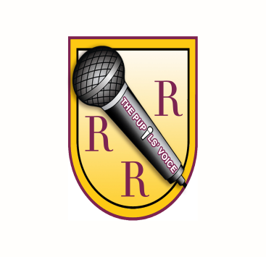
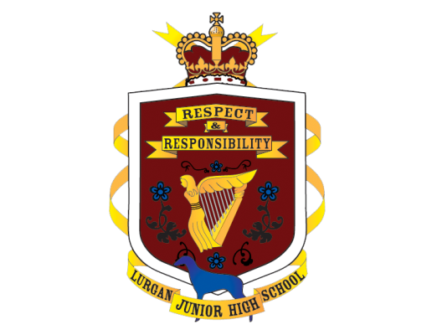
The Pupils’ Voice
Charter

We, the Pupils’ Voice of LJHS, are here to listen to your views, share your ideas and work with the staff, Principal and Governors to make our school a great place to be.

The members of the School Council agree that we will:
- Listen to all suggestions and ideas
- Report back and discuss ideas from the Pupils’ Voice meetings to the classes we represent
- Always respect other people’s opinions and points of view
- Always work together as a team
- Learn to negotiate ideas and suggestions
- Always set a good example and be responsible and reliable
- Persevere to see ideas are carried out
- Take our role seriously

Signed by:
Chairperson -
_________________________________________
Secretary –
_________________________________________
Vice Chairperson –
_________________________________________
Council members:
_________________________________________
_________________________________________
_________________________________________
_________________________________________
_________________________________________
_________________________________________
_________________________________________
_________________________________________
_________________________________________
Link Teacher - Mrs Kerr ______________________

